**Project Initialization and Planning Phase**

| Date | 05/07/2024 |
| --- | --- |
| Team ID | team-739866 |
| Project Name | Revolutionizing Liver care : Predicting Liver cirrhosis using Advanced machine learning Techniques |
| Maximum Marks | 3 Marks |

**Define Problem Statements (Revolutionizing liver care: predicting Liver cirrhosis using Advanced machine Techniques Template):**

Liver cirrhosis is a significant health concern worldwide, characterized by irreversible scarring of the liver tissue. Early detection and timely intervention can greatly improve patient outcomes and reduce healthcare costs. Traditional methods of diagnosis often rely on invasive procedures or are based on symptoms that manifest in later stages of the disease, leading to delayed treatment and poorer prognosis.

In this project, the goal is to develop a robust predictive model using advanced machine learning techniques to accurately identify individuals at risk of developing liver cirrhosis. The model will utilize a combination of demographic data, medical history, lifestyle factors, and potentially biomarkers to predict the likelihood of cirrhosis onset within a specified timeframe.

**Example:**

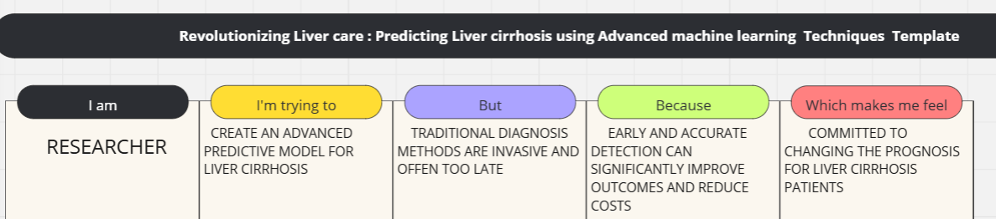

|  |  |  |  |  |  |  |
| --- | --- | --- | --- | --- | --- | --- |
| **PROBLEM STATEMENT** | **IAM** | | **I’M TRYING TO** | **BUT** | **BECAUSE** | **WHICH MAKES ME FEEL** |
| In this project, the goal is to develop a robust predictive model using advanced machine learning techniques to accurately identify individuals at risk of developing liver cirrhosis. The model will utilize a combination of demographic data, medical history, lifestyle factors, and potentially biomarkers to predict the likelihood of cirrhosis onset within a specified timeframe. | | A Researcher focused on liver health.  **-** | Predict liver cirrhosis onset.  - | Current diagnostics are late and invasive  **-** | Non-invasive ,early detection is crucial.  **-** | Motivated to improve prognosis.  - |